Welcome to the Python coding assessment. In this assessment, you will be tasked with implementing a ChatGPT Bot script that interacts with the OpenAI API. Your goal is to create a simple API with CRUD (Create, Read, Update, Delete) operations to manage the ChatGPT bot.

Instructions:

* You may use any Python version you are comfortable with (Python 3.x is recommended).
* This project should be done with Flask
* You are free to use any libraries necessary, including OpenAI Python library (openai).
* Use informative variable and function names to enhance code readability.
* Ensure that your code is well-documented with appropriate comments.
* Keep the API design simple and easy to understand.
* You can use any data storage method you prefer for CRUD operations (e.g., in-memory data structures, file storage, etc.).

Task Description: Your task is to create a Python class for the ChatGPT Bot API with the following functionalities:

initialize_gpt3() - This method should initialize the OpenAI API with the required credentials and settings.

create_prompt(prompt) - This method should take a user-provided prompt as input and store it for later interactions with the ChatGPT bot.

get_response(prompt_index) - This method should take the index of a previously stored prompt and return the ChatGPT bot's response to that prompt.

update_prompt(prompt_index, new_prompt) - This method should update an existing prompt at the given index with a new prompt provided by the user.

Please note that you should interact with the OpenAI API to generate responses to user prompts.

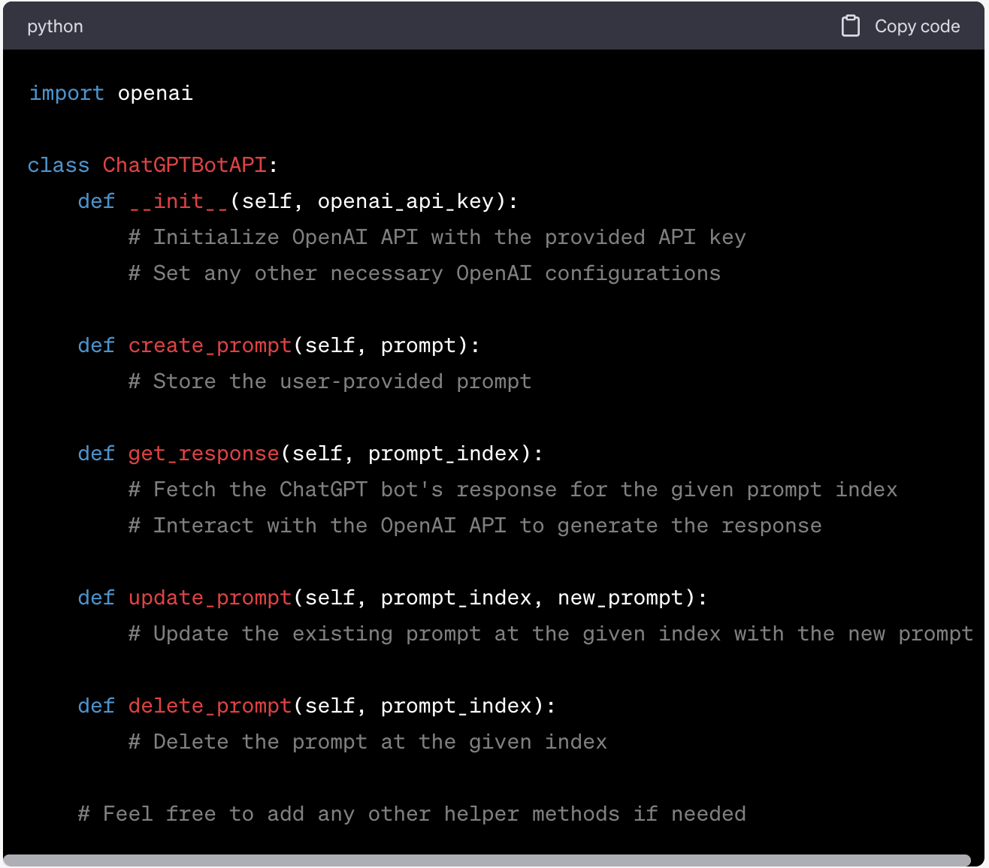

**After this you should create a file for CRUD operations which will be used to interact with the class above. This should contain the endpoints which will be called to interact with the Chatbot API.**   
  
  
Assessment Submission Guidelines:

Implement the ChatGPTBotAPI class with all the specified methods.

Test your implementation with various scenarios to ensure correctness and functionality.

Provide a brief explanation of your code, including any assumptions made, and how you handled interactions with the OpenAI API.

Upload the code as a github repo and share the url

Send your submission to the hiring team by the deadline provided.

Good luck with the assessment! If you have any questions, feel free to ask for clarifications. Remember to follow best practices and keep the code clean and maintainable. Happy coding!